**CHAPTER 2**

**REVIEW OF RELATED LITERATURE AND STUDIES**

RELATED LITERATURE

(Gunathilake, Indrathilake, & Wedagedera, 2009) proposed an opensource web based MIS for the University of Ruhuna, Sri Lanka. This they were able to implement with the LAMP/WAMP technologies. They were able to categorize their users based on administrator, super admin, top admin, general, lecturer and student. The pilot version was targeted at their Faculty of Science and they achieved a password encryption with the primary DES algorithm. 19

(Mariusz , 2010) in his solution University Study-Oriented System (USOS) in Poland stated that the main functional parts are the admin, web, admission/registration of students, database of results, course and diploma catalog, statistics etc. According to him, this solution is used by 27 higher education Polish institutions. In such a system, before transferring any module for production use it has to pass through sample database and university test. Documentation comprising system specification and implementation were updated regularly. Such solutions enhance communication between students and lecturers, proper security measures to prevent against Cross-site request forgery.

(Bharaagoudar, Geeta, & Totad, 2013) developed a web-based Student Information Management System in India which could send emails to students to validate their mailbox on registration. They were able to achieve this using technology such as HTML, CSS, Javascript, PHP and SQL. According to their description, it is a paperless work that assists in automating existing manual methods and can be remotely monitored and controlled on a server based network, the SIMS developed had no built-in security measures to prevent SQL injection.

(Hemn & Wu , 2014) proposed a system in China that can provide students’ general and educational information. According to them, the Students Information Management System (SIMS) can be used to create, read and update the details of a student and also generate reports about his/her skills and experience. Such systems save time of retrieval and prevent data loss.

An Information System (IS) can be any organized combination of people, hardware, software, communications networks, data resources, policies and procedures that stores, retrieves, transforms and disseminates information in an organization. (O'Brien & Marakas, 2011).

(Pinho et al. and Saghapour et al.) refer that web portals have revolutionized the way the academic community interacts and communicates [3,4]. Pinho et al. and Bawack and Kamdjoug argue that this technology enables the integration of all the institutional information, applications, and tools into a single system, thereby facilitating the procedures and changing the way of communicating, the working relationships, and the teaching and learning activities [3,5]. As mentioned by Pinho et al., the resistance to the implementation of these web tools can make information management and success of the HEIs increasingly difficult, i.e., the acceptance of the technology is fundamental for the successful use of these platforms [3].

Providing the best education to children is vital for their overall growth and development. As a result, parents take their time to know everything about the schools they have shortlisted for their child. They visit school websites and look for relevant testimonials before enrolling their kid in any school. A school website is crucial as it is the first point of interaction between schools and parents. That’s why schools need an impressive website with all relevant information to attract the attention of parents and potential students. The website for schools is a mirror for the school management as it affects their overall image and reputation. An impressive website containing relevant information is vital to increase the number of admissions to the educational institution ([DIVYANSH BORDIA](https://blog.teachmint.com/author/divyansh/), 2022).

Online education has transformed the way we approach learning, offering convenience, flexibility, and access to education for people from all walks of life. It has become a popular option for students of all ages, with online courses available from some of the world's top universities, covering a range of subjects and fields. However, with the widespread adoption of online education, there has been an ongoing debate about its impact on learning outcomes.

One of the main advantages of online education is the flexibility it offers. Students can access course materials and lectures at their convenience, and they can learn at their own pace. This means that people with busy schedules, such as working adults or parents, can fit education into their lives in a way that suits them. Online education also removes geographical barriers, allowing students from around the world to access courses from anywhere with an internet connection (Valentine Ubah, 2023).

Nowadays, technological advances in providing transformations in the school scenario, and one of them are the drastic change in secondary school management during the digital era. The purposes of this research were 1) to study the current situations and problems of secondary school management during the digital era; 2) to study the scenarios of secondary school management during the digital era in the next decade (2022-2031). The research specifically looked into 4 core missions of secondary school: 1) management of teaching and learning 2) personnel management 3) budgeting and 4) educational management. The research was conducted in 2 phases. Phase I: studying the current situations and the problems of secondary school management during the digital era by using a questionnaire to collect data from a sample group of 230 secondary school administrators. Phase II: studying the scenarios of secondary school management during the digital era in the next decade (2022-2031) using Ethnographic Delphi Futures Research (EDFR) for 3 parts. Part 1: Interviewing 19 experts using a semi-structured interview form and then analyzing and synthesizing the future tenders (scenarios). Part 2: Assessing the feasibility and the appropriateness of the scenarios by using a 5-level scale questionnaire. The statistics used were median and interquartile range. Part 3: Confirm trend scenarios of secondary school management during the digital era in the next decade (2022-2031). The findings revealed that the current situations of practice are all at a high level and the problems of the management are all at a moderate level. The scenarios of secondary school management during the digital era in the next decade (2022-2031) consist of 4 key elements and 40 possible trends, namely: 1) management of teaching and learning in the digital era with 15 possible trends; 2) educational personnel in the digital era with 10 possible trends; 3) budget in the digital era with 6 possible trends; and 4) educational management in the digital era with 9 possible trends (Thasai, Sakdadach; Sirisuthi, Chaiyuth; Aksornsua, Pha, 2023).

(Tubin, Dorit; Klein, Sarit 2007) Over the past few years, as part of the Information and Communication Technology (ICT) reform on the one hand, and the increased demands for school accountability on the other, more and more schools have launched a school website aimed at enhancing educational activities, supporting student-teacher communication, contributing to school marketing efforts, and fostering accountability to and collaboration with the school's constituency. A large body of research on ICT-based pedagogical and educational websites reveals the contributions of such websites to the schooling process. However, the phenomenon of school websites, which serve the school organization in its entirety, remains relatively unexplored. In this study, the authors explore the contents and structure of school websites and their responsiveness to their school's environment. They briefly review the literature regarding school websites, describe the institutional theory that provides the conceptual framework for the study, present the study methods and findings, and finally discuss the results and suggest practical implications for accountability-oriented school website development.

Management information systems (MIS) programs were developed to prepare graduates to create innovative solutions to problems where business and technology intersect. As such, the curricula must change rapidly to stay current with industry standards, an accelerating moving target. This research presents the findings of a systematic literature review to identify and present trends in the scholarly literature on MIS education. The purpose of this approach was to understand how academia ensures students are prepared for industry and keeps pace with changing industry needs. Key findings from the literature are presented, as well as a compilation of areas for future research. Overwhelmingly, a lack of international perspective was identified as the vast majority of articles collected data in the US. Further, the direction of future research and exploration revolved around five themes of innovative pedagogical approaches, industry partnerships, subtopics of MIS education, new methods and metrics for measuring success in MIS education, and cross-disciplinary opportunities in fields such as mathematics, traditional business disciplines, and the hard sciences (Elrod, Cassandra C.; Stanley, Sarah M.; Cudney, Elizabeth A.; Hilgers, Michael G.; Graham, Cameron , 2022).

RELATED STUDIES

This chapter discuss the history and state of the art of the web, web applications and web application vulnerabilities, also relevant literatures were review under the domain of information system security and web application security.

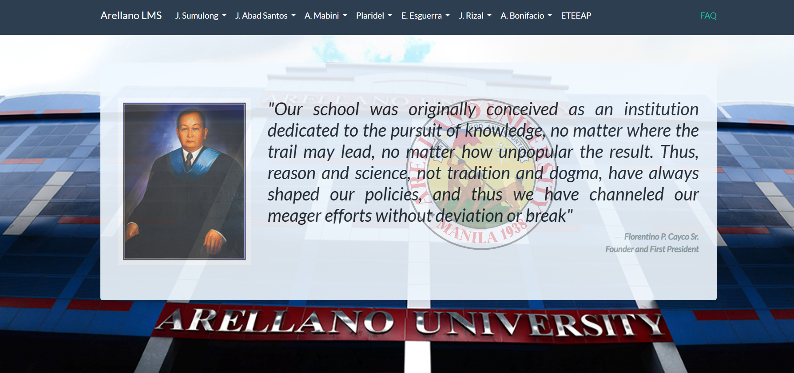

Figure 2.1 : [Arellano LMS (topservelms.com)](https://www.topservelms.com/)

The Arellano University seal was inspired by the heroic photograph of American marines raising the Stars and Stripes on the summit of mount Surabachi. The seal was prepared by the great artist, Vicente Manansala. The whole design is expressive of the faith of the Arellano University in the youth of the land as builders of the Filipino nation.

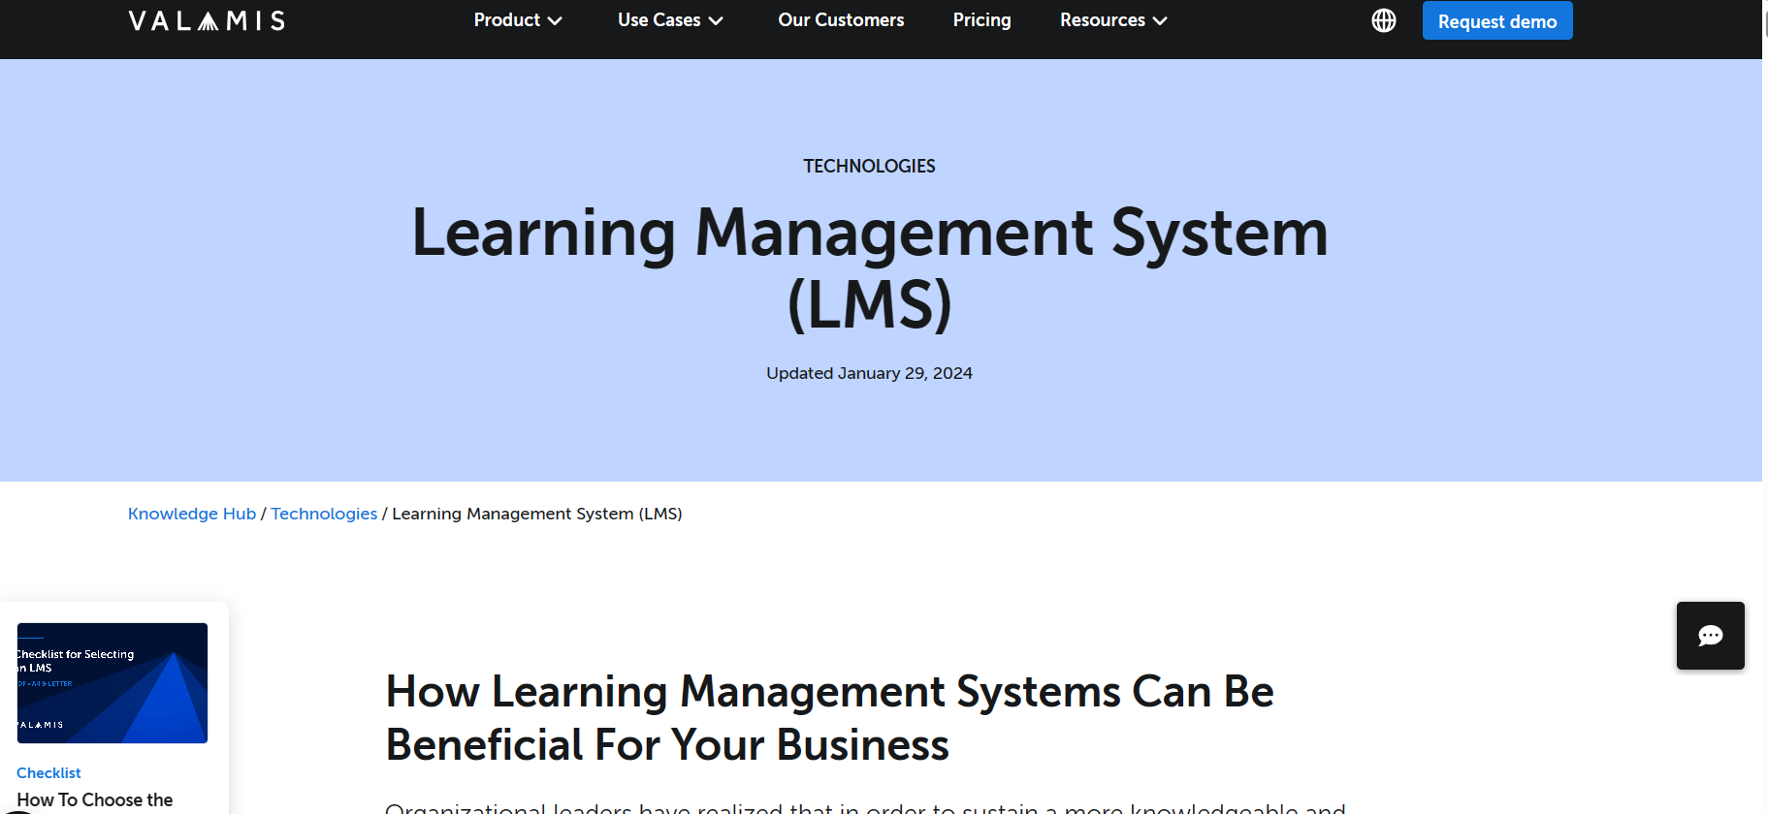

Figure 2.2: [What is a Learning Management System (LMS) | Overview (valamis.com)](https://www.valamis.com/hub/what-is-an-lms)

As a whole, learning management systems help to streamline learning activities in any organization.

REFERENCE:

<https://www.valamis.com/blog/lxp-vs-lms>

<https://www.bing.com/search?q=arellano+lms+about&qs=HS&pq=are&sk=HS1&sc=10->3&cvid=925E5850E47A4692A2CF8120EDF2E333&FORM=QBRE&sp=2&lq=0#

<https://www.bing.com/ck/a?!&&p=6b11eb3d31e773d7JmltdHM9MTcxMDg5MjgwMCZpZ3VpZD0wMjBiNmE3MS0xMjZlLTY2N2YtMGFiYS03ZTcxMTNjMDY3YjUmaW5zaWQ9NTE4Nw&ptn=3&ver=2&hsh=3&fclid=020b6a71-126e-667f-0aba-7e7113c067b5&psq=IJRPR5367.pdf&u=a1aHR0cHM6Ly9panJwci5jb20vdXBsb2Fkcy9WM0lTU1VFNi9JSlJQUjUzNjcucGRm&ntb=1>

https://www.bing.com/ck/a?!&&p=2ccf5feb7d844f42JmltdHM9MTcxMDg5MjgwMCZpZ3VpZD0wMjBiNmE3MS0xMjZlLTY2N2YtMGFiYS03ZTcxMTNjMDY3YjUmaW5zaWQ9NTE5OQ&ptn=3&ver=2&hsh=3&fclid=020b6a71-126e-667f-0aba-7e7113c067b5&psq=2211.00072.pdf&u=a1aHR0cHM6Ly9hcnhpdi5vcmcvYWJzLzIyMTEuMDAwNzI&ntb=1